Wireframe Document

Overview
The wireframe for the Credit Card Fraud Detection project outlines the design and layout of the user interface (UI). The wireframe ensures that the UI is intuitive, user-friendly, and aligned with the project’s objectives. This document provides a detailed description of the interface components and their functionality.

Key Components
- Header: The header includes the title of the application, providing a clear indication of the application’s purpose.
- Input Form: A form where users input the feature values required for the prediction.
- Prediction Result Area: Displays the prediction result after the user submits the form.

Layout Description

Header
- Position: Top center
- Content: Application title "Credit Card Fraud Detection"
- Style:
  - Font: Bold, large font size
  - Color: Dark
  - Alignment: Centered

Input Form
- Position: Centered below the header
- Content: A text area for entering the 23 feature values
- Labels and Instructions: Clear label for the input field and placeholder text within the text area
- Button: A "Predict" button to submit the form
- Style:
  - Text area: Standard font size, sufficient padding
  - Button: Prominent color (e.g., blue), centered, large size for easy clicking
  - Instructions: Smaller font, light color to avoid distraction but clear enough to read

Prediction Result Area
- Position: Below the input form
- Content: Displays the prediction result in an alert box
- Style:
  - Alert box: Informational style (e.g., light blue background)
  - Font: Bold for the result, standard size for additional text
  - Alignment: Centered within the container

Home Page:

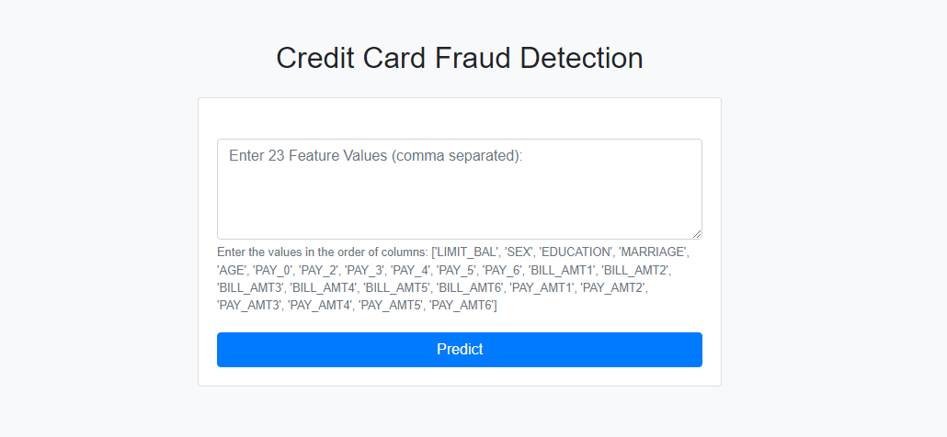

Prediction:

